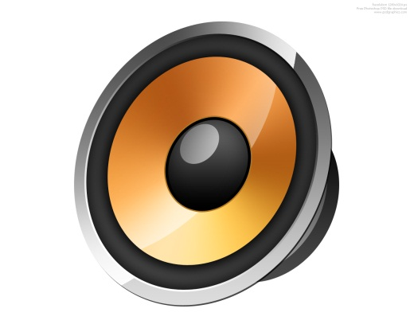Windows Audio

**COMP4985 – Data Communications / Internetworking Comm Audio Project**

Albert Liao – [liao.a17@gmail.com](mailto:liao.a17@gmail.com)

Callum Styan – [callumstyan@gmail.com](mailto:callumstyan@gmail.com)

Steve Lo – [kashun_lo@hotmail.com](mailto:kashun_lo@hotmail.com)

Darry Danzig – [darry.d@gmail.com](mailto:darry.d@gmail.com)

Table of Contents

Design 2

Channel Layout 2

# Design

## Channel Layout

Three types of channels:

1. TCP control channel
   1. used for sending control information like a song list, addition of a song, request for different song or different part of song
2. UDP streaming channel
   1. opened for actually playing the song from the client. the stream will be buffered
3. TCP download / upload channel
   1. only opened when an upload / download request is made. closed after download/upload is finished.